The fifth MCI group Project client meeting will be held in Teams at 16.30 pm on Thursday 8 April 2021

Agenda

**Chair:** Runtao Zhuge

**Secretary:** Menghan Li

**1 Apologies**

None.

**2 Presentation**

None.

**2.1 Functional requirements and Presentations in Last Meeting**

The team members raised some previous questions, and they were not sure about the tools to be used, and the client gave specific answers. In

addition, the client gave some samples and templates to explain what the

project should look like and what specific functions are mainly to be

implemented.

**2.2 Problems and solutions**

1. The clients recommend some tools for us.

2. We find out a similar website from some conference management software. Which is this link:  <https://pkp.sfu.ca/ocs/>

the picture of this website is shown below:

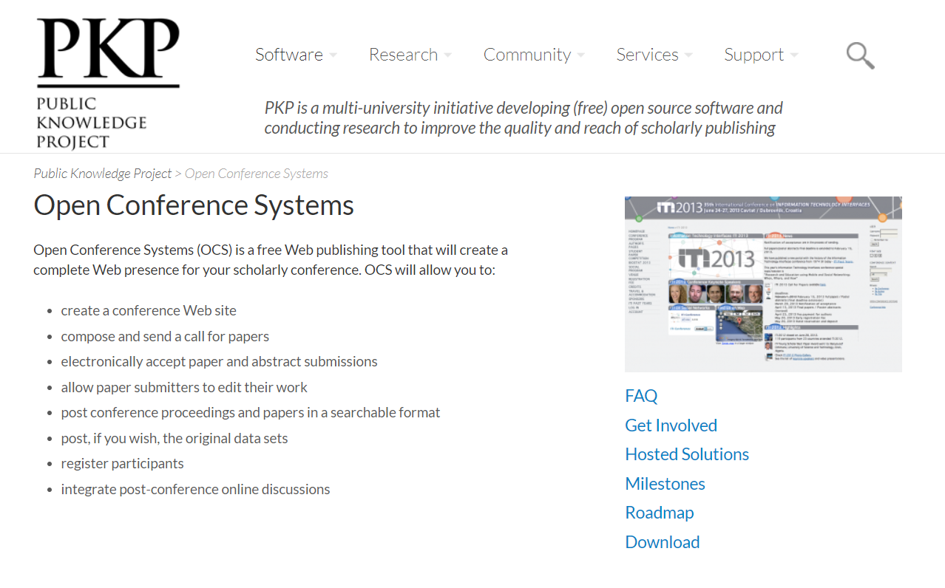

**3 Requirements Elicitation**

3.1 The interface of this website seems good. We could reference this page to design our project.

3.2 The functions of most conference management software are similar with our website. We can use those functions as well.

**4 Other Issues**

What should we need to do in the next two weeks because there is a holiday at this time?

**Note: Next meeting will be held on 29th April 2021**